|  |  |
| --- | --- |
| NAME | Muhammad Arslan Raza |
| ROLL# | 2020-EE-403 |

**Lab 9: Problem Set 3**

**Objective:** The objective of this problem set is how to write different programs on compiler

**Task 1:**

An integer greater than 1 is said to be prime if it is divisible by only 1 and itself. For example, 2, 3, 5 and 7 are prime numbers, but 4, 6, 8 and 9 are not.  
i) Write a function that determines whether a number is prime.  
ii) Use this function in a program that determines and prints all the prime numbers between 2 and 1,000.  
iii) Initially, you might think that n/2 is the upper limit for which you must test to see whether a number is prime, but you need go only as high as the square root of n.  
Rewrite the program and run it both ways to show that you get the same result.

**i)**

**Code:**

def print_prime(n):

count=0

for i in range(1,n):

if n%i==0:

count=count+1

if count==1:

print("Given number is prime",n)

else:

print("Given number is not prime")

num=int(input("Enter the number="))

print_prime(num)

**Output:**

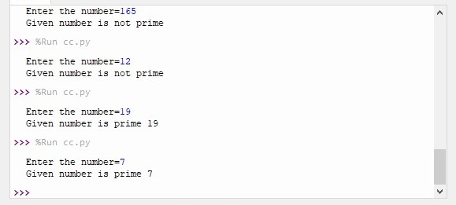

**ii)**

**Code:**

def print_prime(n):

count=0

for i in range(1,n):

if n%i==0:

count=count+1

if count==1:

print(n,end = ' ')

print('prime numbers are=')

for x in range(2,1000):

print_prime(x)

**Output:**

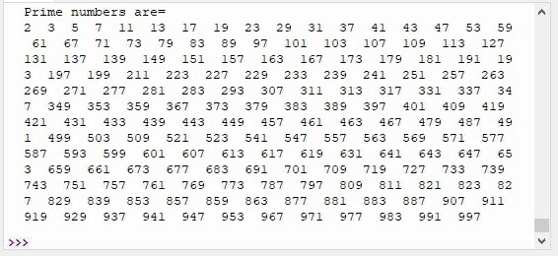

**iii)**

|  |  |
| --- | --- |
| **Code:**  def print_prime(n):  count=0  y= int(n/2)  for i in range(2,y+1):  if n%i==0:  count=count+1  if count==0 and n!=1:  print("Given number is prime")  else:  print("Given number is not prime")  num=int(input("Enter the number="))  print_prime(num)  **Output:** | **Code:**  def print_prime(n):  count=0  y=int(n**1/2)  for i in range(2,y+1):  if n%i==0:  count=count+1  if count==0 and n!=1:  print("Given number is prime")  else:  print("Given number is not prime")  num=int(input("Enter the number="))  print_prime(num)  **Output:** |

**Task 2:**

Implement the following function:

a) *factors (n)*–displays all factors of the number *‘n’* passed as parameter.

b) *display (start, end)* –this function takes the start and end of a range as parameter  
and calls the above function *factors ()* to display the factors of all numbers in that  
range.  
Now call the function *display ()* in a program. Take the start and end of a range from the  
user and pass it to the function to display the factors.

**a)**

**Code:**

def print_factor(n):

print("Factor of Number",n,"are=")

for i in range(1,n+1):

if n%i==0:

print(i)

num=int(input("Enter the number"))

print_factor(num)

**Output:**

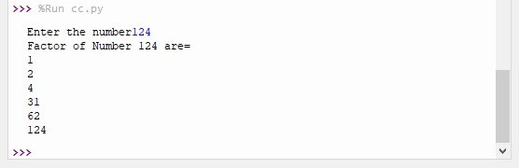

**b)**

**Code:**

def factors(x):

for n in range (1,x):

if x % n == 0:

print(n,end = ' ')

def display(start,end):

for n in range(start,end+1):

print(n,'Factors are=',end = ' ')

factors(n)

print()

start = int(input('Enter Starting point= '))

end = int(input('Enter Ending point= '))

display(start,end)

**Output:**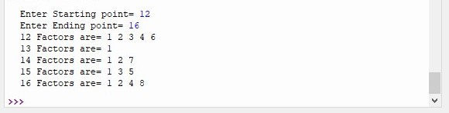

**Conclusion:**

Today I learn how to determine the prime number. And learn how to find out the factors of given numbers.